Fast**National University of Computer & Emerging Sciences, Karachi  
Spring-2021 CS-Department  
MidTerm 1  
19th of March 2021, 11:00a.m– 12:00 noon**

|  |  |  |
| --- | --- | --- |
| **Course Code: CS301** | **Course Name: Theory of Automata** | |
| **Instructor Names: Mr. Shahzad, Shaharbano, Bakhtawar, Musawar** | | |
| **Student Roll No:** | | **Section No:** |

Instructions:

* Return the question paper.
* Read each question completely before answering it. There are 5 **questions and 2 pages**.
* In case of any ambiguity, you may make assumption. But your assumption should not contradict any statement in the question paper.
* Start each question in a new sheet.

**Time**: 60 minutes. **Max Marks:** 55 points

**Question 1: (5+5) Points**

**A vending machine is an automated selling machine. Give a DFA and the transition table for this machine that sells a number of items (chips, candies, etc.) for 4 rupees each. It accepts only 1 and 2 rupees, and refunds all money if more than 4 rupees is added. Multiple items can be purchased in one go. The accepted strings are the language defined by this vending machine automaton. Following are the some of the accepted and rejected strings for this language:**

**- Ɛ (reject)**

**- 22 (accept)**

**- 1222 (reject)**

**- 1222221111 (accept)**

**-222 (reject)**

**- 1111 (accept)**

**- 2222 (reject)**

**- 22222 (accept)**

**[Hint: There can be one accepting state.  Refund amount returns you to the start state in DFA and the amount become ZERO up to that letter (rupees) in any given input string.]**

**Question 2: (DFA) (5+3+5) Points**

1. **Find the DFA for the language L of string which does not contain the substring bb and ends with 'a' defined over alphabet {a, b}.**
2. **Construct the FA for the following regular expression.** **1*(0*01*) *+1+0+λ**
3. **Find the DFA corresponding to set of strings with either no 1 preceding a 0 or no 0 preceding a 1.**

**Question 3: (Regular Expressions) 12 Points**

**Express each of these languages over Σ = {0, 1} using a regular expression.**

**a) L1 the set consisting of the strings 0, 11, and 010**

**b) L2 the set of strings of three 0s followed by two or more 0s, containing no 1s**

**c) L3 the set of strings of odd length**

**d) L4 the set of strings that contain exactly one 1**

**e) L5 the set of strings ending in 1 and not containing 000**

**f) The set of strings containing a string of 1s such that the number of 1s equals 2 modulo 3, followed by an even number of 0s**

**Question 4: (Conversion epsilon-NFA to DFA) 10 Points**

**Construct the DFA from the Epsilon NFA given in figure 1.**

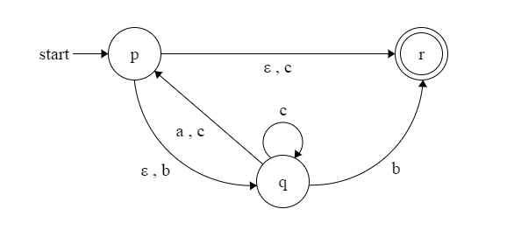

Figure 1

**Note: Show steps of your method properly to get full credit.**

**Question 5: (GTG and State Elimination) 10 Points**

**Find the regular expression of the DFA given in figure 2, using state elimination method.**

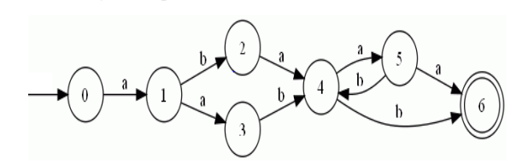

Figure 2

**Note: Show steps of your method properly to get full credit.**

***BEST OF LUCK!***